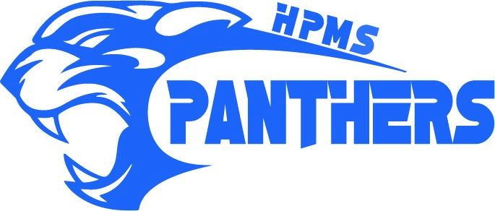
90 St. Lawrence Avenue, Oromocto, NB E2V 1T2 Phone: (506) 357-4070 Fax: (506) 357-3604
Harold Peterson Middle School (nbed.ca)
SCHOOL SUPPLY LIST 2025 - 2026
GENERAL SUPPLIES REQUIRED FOR ALL GRADES
Individual teachers will notify families throughout the school year when additional supplies are needed.

- 10-pack page protectors
- 2 highlighters
Please feel free to label any and all of your child’s belongings and supplies, it may help keep our lost and found items to a minimum. This includes coats, lunch bags, water bottles, etc.

- Pencil Case
- Pens (black & blue, 10-15)
- Pencils (60+)
- Erasers
- Coloured pencils
- Glue stick
- Markers
- Ruler
- Small pair of scissors
- 6-8 Duotangs
- 1 Scrapbook for Art (Dollar Store variety is fine)
- Packages of loose leaf paper (1000+ sheets)
- 1 - 2” Binders (zippered or non-zippered)
- 1 Package of 8 Dividers
- 1 Math Compass Set (metal preferred – a good quality math set can be used each year)
- 1 Calculator (cell phones will not be permitted to be used as calculators)
- 1 Pencil Sharpener
- 2 Boxes of Kleenex
- 1 French/English dictionary
- 1 Package of Four, Hilroy Notebooks (minimum 32 pages), no coils
- 1 Package of Graph Paper
- 4-6 Dry-Erase Markers
- A campfire style notebook is good for communication between home and school and/or notes.
- Personal Ear Buds/Headphones – ALL STUDENTS MUST HAVE THEIR OWN FOR COMPUTER LAB
- WATER BOTTLE, for each day

IN ADDITION TO THE ABOVE, THE FOLLOWING IS REQUIRED FOR THESE GRADES:

Grade 6 | ALL French Immersion - Grades 6, 7 & 8
Coiled notebook of graph paper  6 English – extra pkg of four Hilroy notebooks | 1 French/French dictionary  1 French/English dictionary  1 Bescherelle (green)

PHYSICAL EDUCATION - A change of clothing for Physical Education is required for all students – t-shirt, shorts or sweatpants and indoor sneakers that are to be used for gym only.
STUDENT FEES: $35.00 per student
Annual student fees are used to provide each student with a cinch sack, use of a lock and locker, school activities, special guests/presentations, some field trips and to supplement transportation costs for them, materials for woodworking and material costs for Art, MakerSpace, Culinary Arts, Panther Assembly prizes, Activity Periods materials, and other educational purposes throughout the year. Minimal supplementary fees may be requested for individual Technology projects and/or field trips, if they are more costly. Our preferred method of payment is through SchoolCash Online – please sign up at https://anglophonewest.schoolcashonline.com

